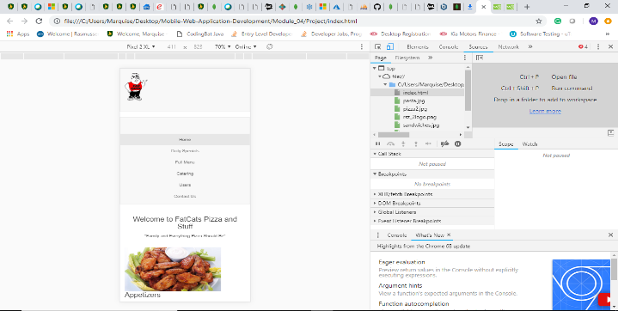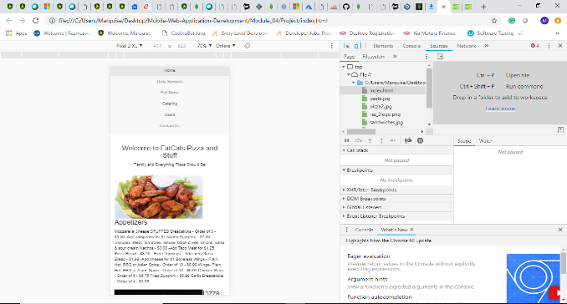

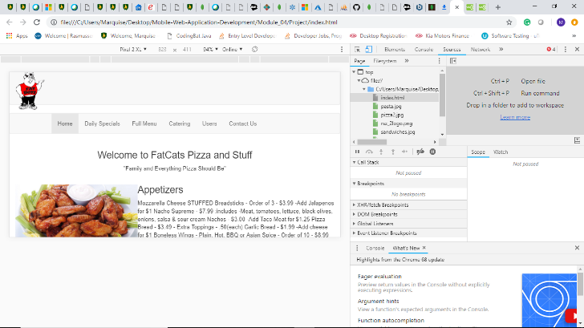

Scaling the webpage for pixel 2 XL shows the images of food in the paragraph area extremely large, I would additionally look to remove the white line between the menu and the logo. However, the issue of the line does not affect the sites usability on this phone. Landscape mode has no layout issues I would mention beside some of the text for images falling under the pictures.

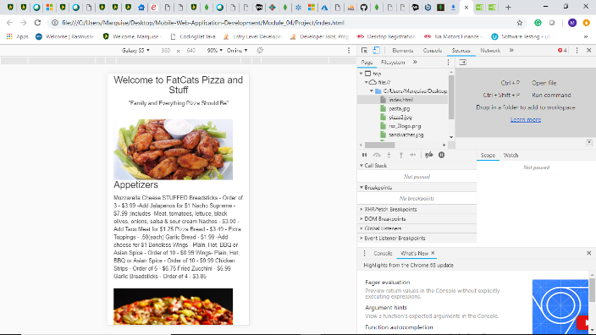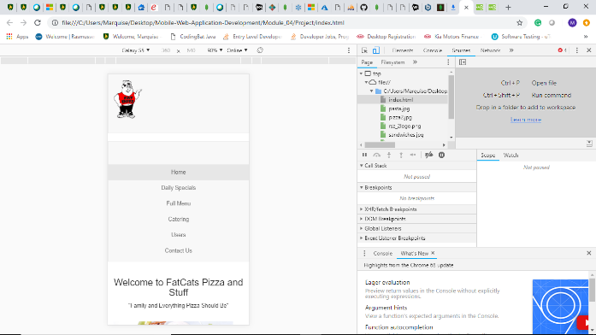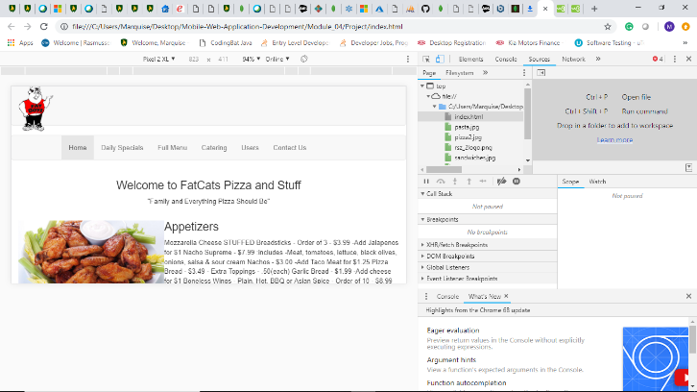

Looking at the mobile view for Galaxy S5 shows the webpage nearly the ideal way I would want the page to look on mobile. The white line at the top still persist and is an annoyance but does nothing to obstruct the usability of mobile. Landscape mode has no layout issues I would mention beside some of the text for images falling under the pictures. Ideally images would align with the left of the screen with text to the right.

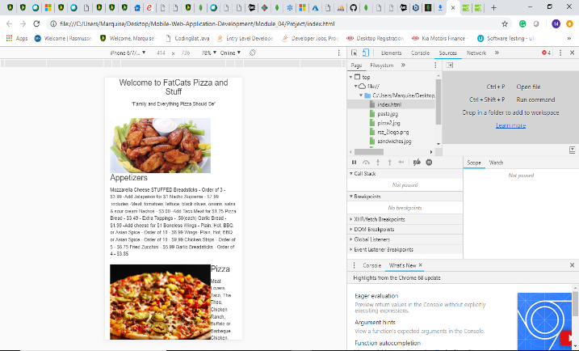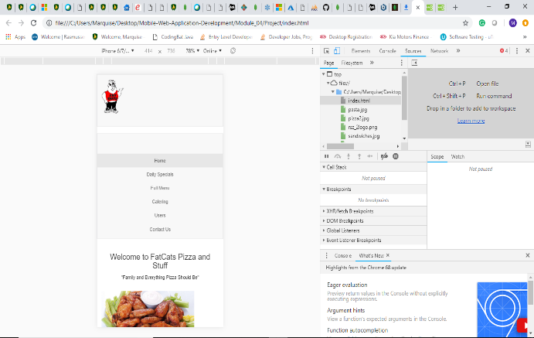

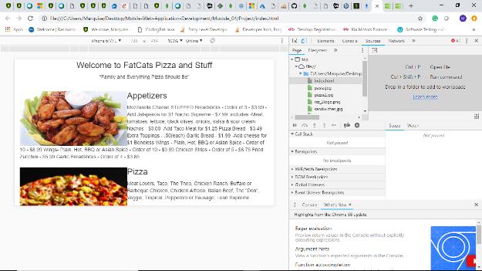

Looking at the mobile view for Iphone 6/7/8 shows the webpage the furthest from where I would like it to appear visually. The images of food fall in an obstructing way near the text. The white line at the top still persist and is an annoyance but does nothing to obstruct the usability of mobile. Additionally the way it looks on Iphone is Landscape mode has little to no layout issues I would mention beside some of the text for images falling under the pictures. Ideally images would align with the left of the screen with text to the right.